**1. System Components**

**1.1 Decomposition Description**

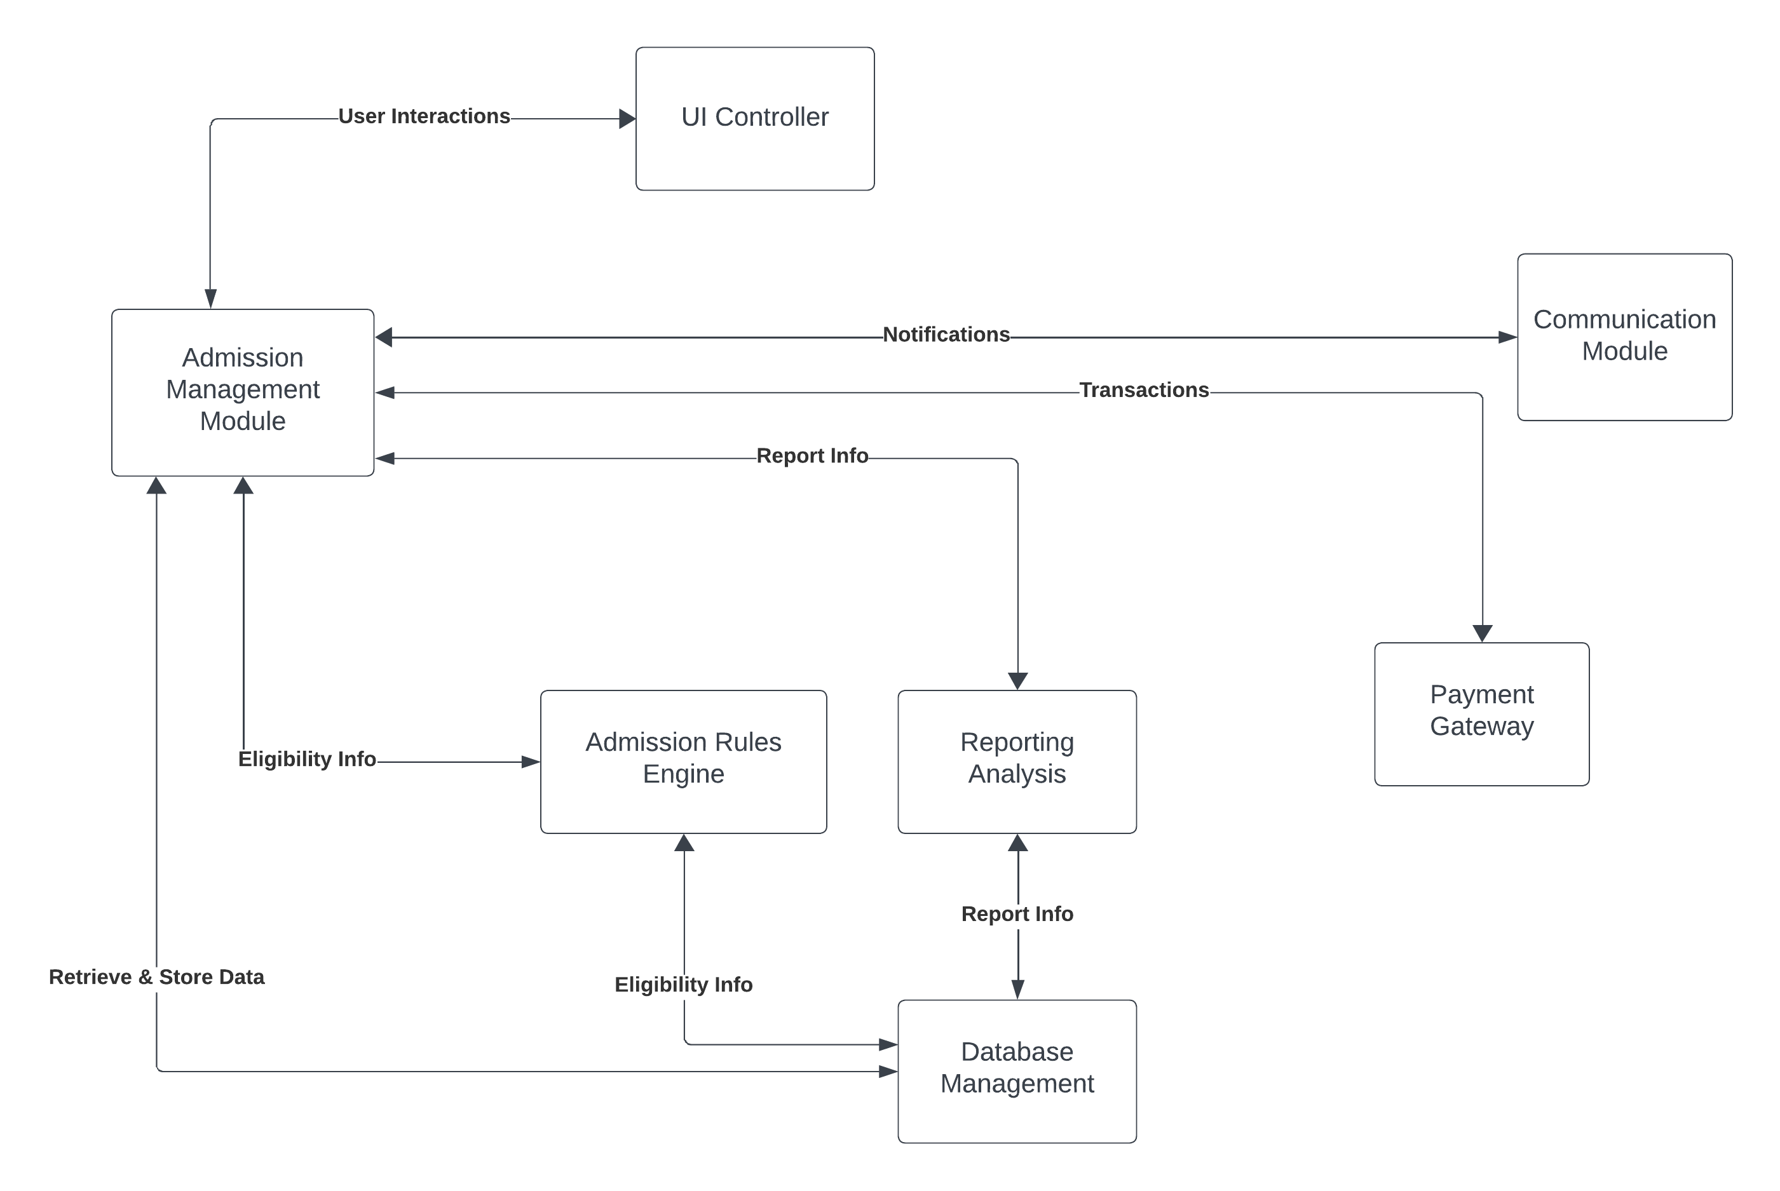

The decomposition of the KCET Admission Automation system involves several key components that work together to facilitate the admission process. These components include:

* **Admission Management Module:** This is the central component responsible for managing all aspects of the admission process. It handles functions such as creating, updating, and retrieving applications.
* **User Interface (UI):** The UI serves as the user's interaction point with the system. It allows applicants, administrators, and institutions to input and retrieve information related to admissions.
* **Database Management:** This component is responsible for storing and managing data related to applicants, institutions, courses, and admissions. It ensures that information is organized and accessible when needed.
* **Admission Rules Engine:** This component defines and enforces the admission rules and criteria. It plays a crucial role in determining eligibility and processing admissions.
* **Reporting and Analytics:** This sub-component generates reports and provides analytical insights for administrators and institutions. It helps in making informed decisions regarding admissions.
* **Communication Module:** The Communication Module handles communication between the system and users, including sending notifications, alerts, and updates.
* **Payment Gateway:** This component facilitates online payment processing for application fees. It ensures secure and efficient payment transactions.

**1.2 Dependency Description**

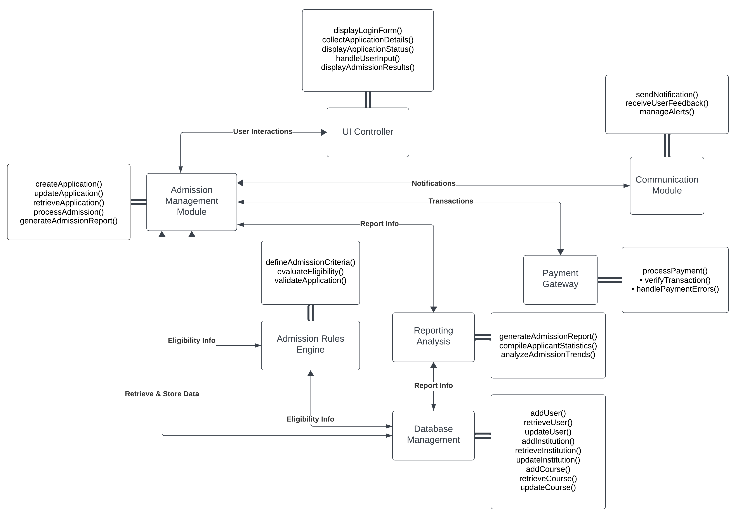

The components within the KCET Admission Automation system are interdependent, each relying on others for their functionality. These dependencies are crucial for the seamless operation of the system. For example, the User Interface (UI) serves as the entry point for users, allowing them to interact with the system. The data provided by the user through the UI flows into the Admission Management Module, which then processes and manages the admission applications. Similarly, the Database Management component works closely with other modules to ensure that relevant data is stored and accessible. Overall, these dependencies ensure that the system functions cohesively and efficiently to manage the admission process effectively.